Decision Maker Personality Assessment with OCEAN (Big Five)
Nov 5, 2026 · Group 03
The Faculty of Information and Communication Technology, Mahidol University. ITCS454 Special Topics in Database Systems, Final Project Part 1 (Business and Data Understanding), taught by Assoc. Prof. Dr. Jarernsri Mitrpanont.
This report replaces the MBTI evaluation from Project 1 with the OCEAN (Big Five) model used in the Meridian prototype. It draws on three datasets, the IPIP Big Five Factor Markers test (1,015,341 responses) for trait scores and percentile norms, and two HR datasets (hr-ana and Employee's Performance for HR Analytics) for the performance and potential axes of a 9-Box Talent Grid. The banking technology domain and internal users stay the same.
Group ID 03 | Student ID
Mr. Punnawit Kanogpornwanich | 6688042
Mr. Bhumipat Pengpaiboon | 6688077
Mr. Napas Siripaskrittakul | 6688108
Table of Contents
1. Motivation and Problem Statement
2. Objectives and Success Metrics (KPI)
3. Business Domain and Internal Users
4. Data Requirements and ER Diagram
5. Software Structure Chart
6. Use Case Diagram
7. Question Model
8. OCEAN and 9-Box Logic Model (IF-THEN Rules)
9. Data Profile and Quality
References

1. Motivation and Problem Statement

Motivation
A bank depends on the decisions of its technology leaders. A wrong call during an incident, a platform change or a digital banking launch can reach customers and regulators, so who holds these roles matters. Past performance alone does not answer that question, because it shows how well someone did in the current role and not how they decide or how far they can grow.
The HR data shows the gap. In hr-ana train.csv (54,808 employees), 8.5% were promoted, and even among employees with the top rating of 5 only 16.4% were, so a high rating does not settle who moves up. In the employee file, 2,044 rated employees (12.7%) sit in the Enigma cell, with high potential but low performance, and only 27.7% of Retail Banking staff met more than 80% of their KPIs.
Personality adds what these records lack. The Big Five traits have a multiple correlation of 0.48 with leadership (Judge et al., 2002), and Conscientiousness is the strongest trait predictor of job performance at 0.19 (Sackett et al., 2022). Project 1 used MBTI, which forces each person into one of 16 types and was not connected to any performance data.

Problem Statement
HR and executives at the bank have no single, comparable view of how a leader decides, how that leader performs and how far they could grow. Succession decisions are therefore hard to justify, and a mismatch between a leader's decision style and the role is found late.

From Business Problem to Analytical Problem
Business question | Analytical problem | Measured by | Decision Maker
How does each leader make decisions, compared with others? | Score the 50 item test into five traits, convert to percentiles and classify a decision profile | KPI 1, 2, 7 | Employee, EM, HR
Who should enter the succession pool? | Rank employees by Leadership Index and place them on a performance by potential grid | KPI 3, 5, 6 | HR, CEO
Which department needs action first? | Compare department rates against the alert thresholds | KPI 2, 3, 4, 6 | HR, CEO, CTO, EM
The personality scores in the employee file are a synthetic link (section 9.1), so the system demonstrates this decision process and does not measure an effect of personality on these employees.

2. Objectives and Success Metrics (KPI)
The system tracks seven KPIs, three from the OCEAN assessment, three from the 9-Box Grid and one for adoption. The rules and layers they use are defined in section 8. Each has a baseline taken from the cleaned IPIP benchmark (592,204 respondents) or the employee file (17,414 employees).
Objectives
- Give every leader a valid, comparable OCEAN profile instead of a forced four letter type, with at least 95% of employees holding a completed result within 30 days of launch (KPI 7).
- Show each department how its decision profiles are spread, so that no single profile exceeds 35% of any department (KPI 2).
- Find executive track leaders and check them against their real performance and potential before placement, with executive fit at 10% or more in every department and every X1 shortlisted employee reviewed by HR (KPI 3, KPI 6).
KPI | Definition | Calculation | Baseline | Alert rule | Decision Maker
KPI 1 Trait Percentile | Each person's percentile on O, C, E, A and N | OCEAN_NORM lookup of the raw score | Median raw O 40, C 34, E 29, A 39, N 31 (all near the 50th percentile) | Yellow when a department's mean percentile on a trait is outside 40 to 60 | Employee, EM, HR
KPI 2 Decision Profile Distribution | Share of results in a team with each of the six profiles | Count with profile p ÷ results × 100 | IPIP C 18.2%, S 17.4%, E 17.4%, O 17.3%, A 16.1%, B 13.5% | Yellow when one profile is over 35% of a team, Red when over 50% | CEO, C-Level, HR, CTO
KPI 3 Executive Fit Rate | Share of results with Leadership Index ≥ 70 | Count with executive fit = Yes ÷ results × 100 | IPIP 12.3%, employee file 14.5% (2,518) | Red when a department falls below 10% | HR, CEO
KPI 4 Performance Index | Percentile of the weighted rating, KPI and award score | Layer 4 formula, rated employees only | High 33.0%, Medium 23.5%, Low 43.5% of 16,051 rated | Yellow when the Low band is over 45% of a department's rated employees, Red when over 50% | EM, HR
KPI 5 Potential Index | Percentile of the promotion model score | Logistic regression, Layer 4 | Thirds by design, model AUC 0.714 | Green when the High band is 33.3% or more of a department, Yellow when below that, Red when below 25% | HR, CEO
KPI 6 9-Box Talent Pipeline | Share of rated employees in each 9-Box cell, and the Star plus executive fit shortlist | Count per cell ÷ 16,051 × 100 | Star 11.5% (1,844), shortlist X1 357 | Yellow when Star share in a department is under 10% | HR, CEO
KPI 7 Assessment Completion Rate | Share of employees with a completed result | Employees with a result ÷ employees × 100 | Prototype seed 88.9% (8 of 9). Live baseline starts at launch | Yellow when below 90%, Red when below 70% | HR
The alert thresholds are a design choice of this report and can be tuned by HR.
At baseline, KPI 4 is Yellow for Retail Banking (49.8%), IT Support (48.8%) and Corporate Banking (47.9%). KPI 5 is Green for Human Resources (41.8%), IT Support (40.1%) and Finance and Accounting (35.3%), and Yellow for the other three. KPI 6 is Yellow for Retail Banking, where Stars are 8.4% of rated employees.
KPI Targets
KPI | Target | Baseline
KPI 1 Trait Percentile | Every completed result has all five percentiles | Met in the employee file
KPI 2 Decision Profile Distribution | No profile over 35% of any department | Highest 27.5%, Finance and Accounting
KPI 3 Executive Fit Rate | 10% or more in every department | Lowest 11.4%, IT Support
KPI 4 Performance Index | Low band at 45% or less in every department | Three departments above 45%
KPI 5 Potential Index | High band at 30% or more in every department | Lowest 29.8%, Customer Service
KPI 6 9-Box Talent Pipeline | Stars at 10% or more of rated employees in every department, and all X1 employees reviewed by HR | Lowest 8.4%, Retail Banking. 357 to review
KPI 7 Assessment Completion Rate | 95% or more within 30 days of launch | Prototype seed 88.9%
The targets are proposed in this report and can be tuned by HR. Performance and potential bands are relative to the current employees, so progress on KPI 4 to KPI 6 should be measured against cut-offs frozen at this baseline.
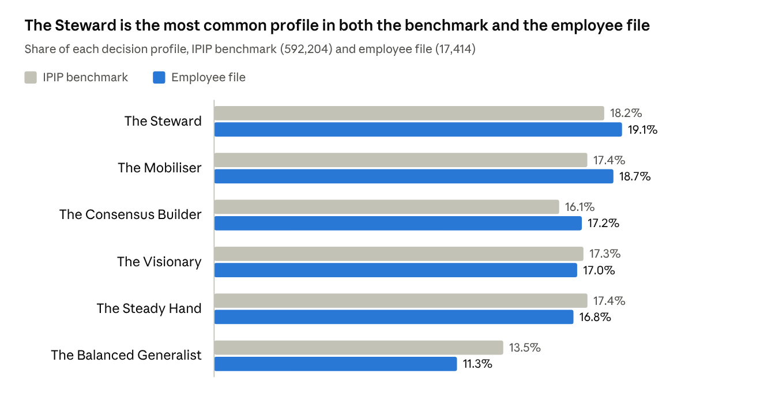
data-final.csv (cleaned) and employees_ocean_hr.csv · 6 decision profiles
The employee file has fewer Balanced Generalists (11.3% against 13.5%) most likely because the department tilts push more people past the 60th percentile on one trait. In a real team, a clear departure from the benchmark is the signal to act on.

3. Business Domain and Internal Users
The business domain is a Banking Technology Company. The system, Meridian, the Decision Style Assessment Tool for Banking Tech Leaders, helps fintech and banking technology organizations understand how Engineering Managers, CTOs and CEOs make decisions in incident response, sprint prioritization, platform architecture, digital banking systems and company wide strategy.
Each employee answers the 50 item IPIP Big Five test. The system scores five traits (Openness, Conscientiousness, Extraversion, Agreeableness, Neuroticism), shows them as percentiles on a five axis pentagon, maps the strongest trait to one of six decision profiles, and computes a Leadership Index that flags executive track profiles. HR then places employees on a 9-Box Talent Grid that combines a performance axis and a potential axis from HR records, so a mismatch between a leader's decision style and the role can be addressed through role placement and leadership development.
OCEAN replaces MBTI because it scores each trait on a continuous scale rather than forcing an either or type, so a leader who sits near the middle of a trait is not pushed into a label, and every score can be compared with a population of 592,204 cleaned respondents.

Application Flows
Flow | Who | Steps
Flow 1, individual assessment | Employees in Retail Banking, Corporate Banking, Customer Service, Finance and Accounting, IT Support | Register, Login, Take OCEAN Assessment, Get Result, Get Suggestion
Flow 2, HR and management oversight | Human Resources, Engineering Manager, Chief Technology Officer, Chief Executive Officer | Register, Login, Check Employee OCEAN Status (dashboard), Suggest Employee (sent by email)
The routing rule runs at Login and Register. A user whose department is Human Resources, Engineering Manager, Chief Technology Officer or Chief Executive Officer goes to Flow 2, and every other department goes to Flow 1.

List of Internal Users
Internal User | Role and Responsibility | Department Scope in Flow 2
Employee | Takes the OCEAN assessment, reads the decision profile and suggestion, and can retake the test | Own result only (Flow 1)
HR (Human Resources) | Monitors assessment status and results, shortlists executive fit profiles, reviews the 9-Box Grid and sends follow up emails | All business departments
CEO (Chief Executive Officer) | Has organization wide oversight and uses profiles, Leadership Index and the 9-Box Grid for leadership and succession decisions | All business departments
CTO (Chief Technology Officer) | Responsible for technology operations, reviews the decision styles of technology staff | IT Support only
EM (Engineering Manager) | Reviews team members' decision styles to support team management | Retail Banking, Corporate Banking, Customer Service, Finance and Accounting

4. Data Requirements and ER Diagram
The system needs twelve entities. The first nine follow the Meridian README (OCEAN version). The prototype stores USER, with its result embedded, and EMAIL_LOG in localStorage, while QUESTION, ANSWER, OCEAN_NORM, DECISION_PROFILE and DEPARTMENT_SCOPE live in code. A production build would move them into tables. The last three, HR_RECORD, TALENT_REVIEW and NINE_BOX_CELL, are added in this report to hold the HR data behind the 9-Box Grid.
Entity | Purpose | Key attributes
DEPARTMENT | The 9 org units and the flow each routes to | department_name (PK), is_hr_access
DEPARTMENT_SCOPE | Which business departments a Flow 2 role may view | viewer_department (PK, FK), viewable_department (PK, FK)
USER | Every account, Flow 1 employees and Flow 2 HR and executives | user_id (PK), name, username, password, email, department_name (FK), is_hr_flow, created_at
QUESTION | The fixed IPIP-50 question bank | question_id (PK), trait, prompt, reverse
TEST_RESULT | One completed assessment attempt | result_id (PK), user_id (FK), score_o, score_c, score_e, score_a, score_n, completed_at
ANSWER | Each answer inside one attempt (scoring audit trail) | answer_id (PK), result_id (FK), question_id (FK), answer_value
OCEAN_NORM | Percentile of each raw trait score | trait (PK), raw_score (PK), percentile
DECISION_PROFILE | Knowledge base, strongest trait to decision profile | profile_code (PK), name, decision_style, decision_style_detail, description
EMAIL_LOG | Follow up and reminder emails sent by HR and executives | email_id (PK), to_user_id (FK), to_email, subject, body, sent_at, sent_by (FK)
HR_RECORD | HR attributes of an employee, from the HR datasets | employee_id (PK), user_id (FK), region, education, gender, recruitment_channel, age, length_of_service, no_of_trainings, avg_training_score, previous_year_rating, kpis_met_more_than_80, awards_won
TALENT_REVIEW | One 9-Box placement of an employee | review_id (PK), employee_id (FK), performance_index, performance_band, promotion_propensity, potential_index, potential_band, nine_box (FK), reviewed_at
NINE_BOX_CELL | The 9 cells of the grid and the action for each | nine_box (PK), label, performance_band, potential_band, recommended_action
TEST_RESULT stores only the five raw scores. Percentiles, the decision profile and the Leadership Index are derived live from OCEAN_NORM and DECISION_PROFILE, so a result never goes stale when the norms or rules change.
TEST_RESULT
Attribute | Type | Key | Notes
result_id | string | PK | ID of the attempt
user_id | string | FK | USER who took the test
score_o ... score_n | int × 5 |  | Raw trait totals, 10 to 50
completed_at | datetime |  | Date the test was completed
OCEAN_NORM
Attribute | Type | Key | Notes
trait | string | PK | O, C, E, A or N
raw_score | int | PK | 10 to 50
percentile | int |  | 0 to 100, mid rank among 592,204 cleaned IPIP respondents
DECISION_PROFILE
Attribute | Type | Key | Notes
profile_code | string | PK | E, C, S, O, A or B
name | string |  | For example The Steward
decision_style | string |  | Short dashboard label
decision_style_detail | string |  | One sentence on how this profile decides
description | string |  | Where the profile fits in a bank
HR_RECORD
Attribute | Type | Key | Notes
employee_id | int | PK | Source employee ID
user_id | string | FK | Linked USER account
department | string |  | Meridian department, mapped from the source
education | string |  | Bachelor's, Master's and above, Below Secondary or Unknown
age, length_of_service | int |  | Years
no_of_trainings, avg_training_score | int |  | Trainings attended and their average score
previous_year_rating | int |  | 1 to 5, can be blank in the first year
kpis_met_more_than_80, awards_won | int |  | 1 or 0
TALENT_REVIEW
Attribute | Type | Key | Notes
review_id | string | PK | ID of the review
employee_id | int | FK | HR_RECORD reviewed
performance_index, performance_band | decimal, string |  | Percentile and Low, Medium, High or Not rated
potential_index, potential_band | decimal, string |  | Percentile and Low, Medium or High
nine_box | int | FK | NINE_BOX_CELL, blank when not rated
reviewed_at | datetime |  | Date of the review
NINE_BOX_CELL
Attribute | Type | Key | Notes
nine_box | int | PK | 1 to 9
label | string |  | For example Star
performance_band, potential_band | string |  | Position on the grid
recommended_action | string |  | HR action for this cell

ER Diagram (Crow Foot)
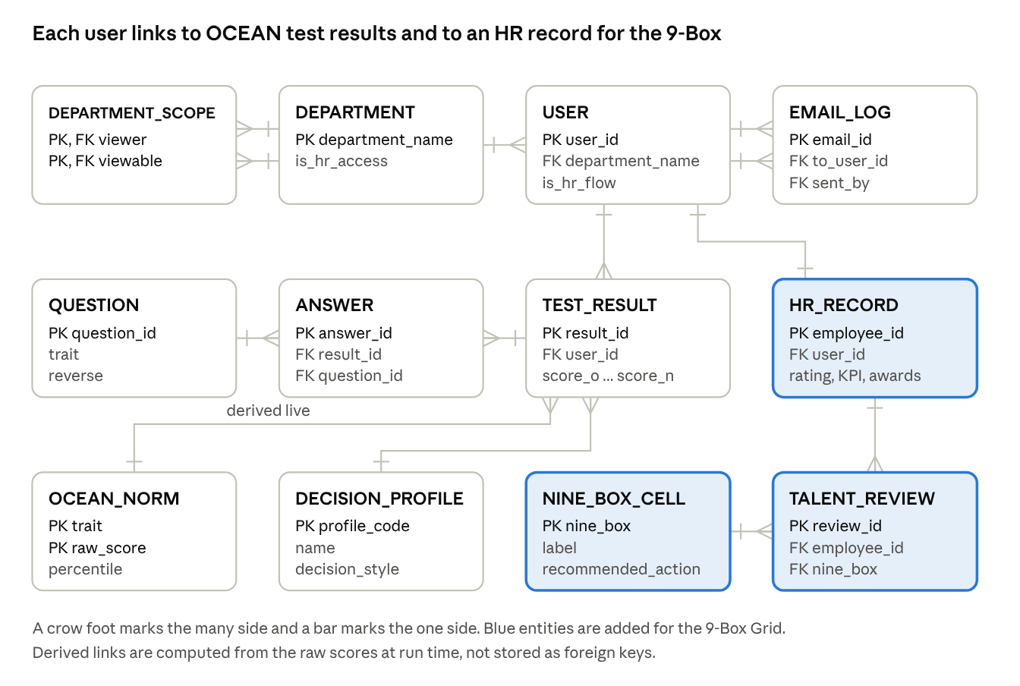
ER diagram · 12 entities, 13 relations

5. Software Structure Chart
The system has three control modules, called from Login and Register. The routing rule (isHrFlow) decides whether module 2 (Flow 1) or module 3 (Flow 2) runs. Four shared data and knowledge modules sit below them with high fan in (lib/store.ts, lib/questions.ts, lib/ocean.ts, lib/oceanNorms.ts). Module 3.5 and the HR data store are added in this report for the 9-Box Grid.
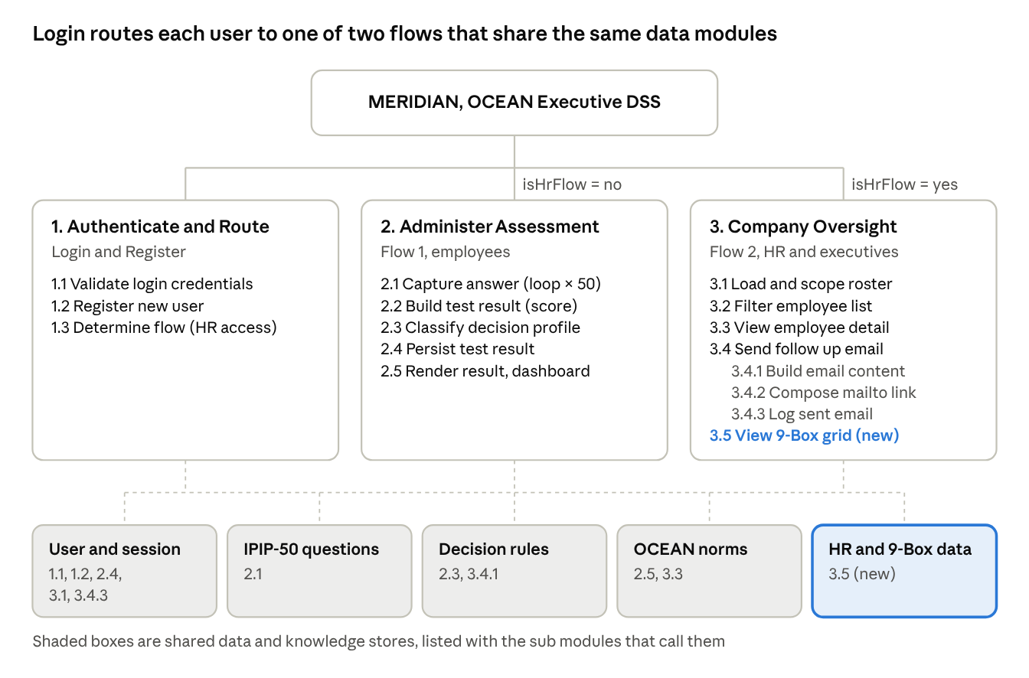
software structure chart · 3 control modules, 5 shared stores (README §3 plus 9-Box)

6. Use Case Diagram
Use Cases
- Register and Login (all users)
- Take OCEAN Assessment, which includes Score Traits, Classify Decision Profile and Compare with OCEAN Norms
- View Result and Suggestion (Employee)
- View Dashboard and Retake (Employee)
- Check Employee OCEAN Status, scoped by department (HR, CEO, CTO, EM)
- Filter Executive Fit Profiles (HR, CEO, CTO, EM)
- View Employee Detail (HR, CEO, CTO, EM)
- Send Follow Up Email (HR, CEO, CTO, EM)
- Export Employee CSV (HR, CEO, CTO, EM)
- View 9-Box Talent Grid (HR, CEO), added in this report
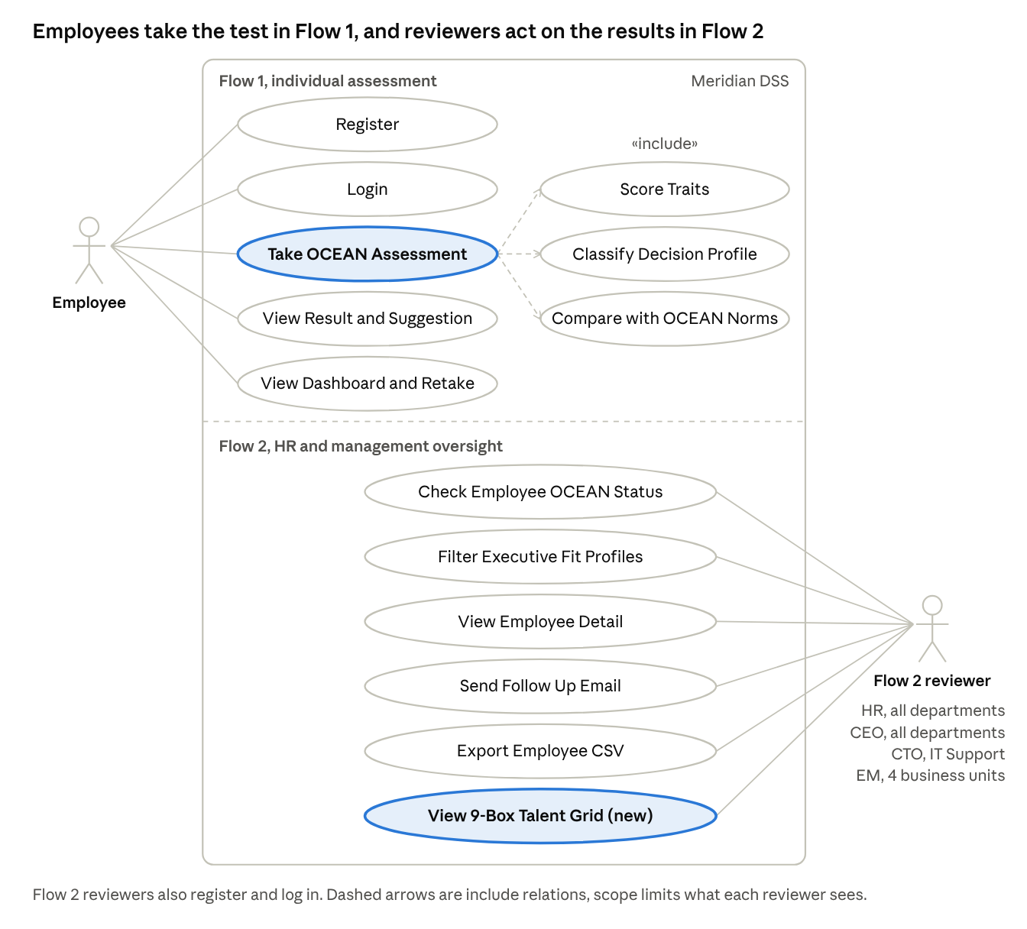
use case diagram · 2 actors, 14 use cases
Employees use Flow 1. HR, CEO, CTO and EM are Flow 2 reviewers who share the same oversight use cases, and each sees only the departments in its scope. Include relations mark the steps that always run when a test is taken, which are scoring the traits, classifying the decision profile and comparing the scores with the OCEAN norms.
The diagram draws one Flow 2 reviewer actor for simplicity, but View 9-Box Talent Grid is limited to HR and CEO, as listed above.

7. Question Model
The test uses the 50 original IPIP Big Five Factor Markers items (Goldberg, 1992), 10 per trait, so every employee answer can be compared directly with the dataset. Each item is rated on a five point scale (1 Disagree, 2, 3 Neutral, 4, 5 Agree). Items marked + count toward the trait as answered, and items marked − are reverse keyed. The app shows one item at a time in the order EXT1, AGR1, CSN1, EST1, OPN1, EXT2 and so on, the same order as the source test, which showed all items on one page.
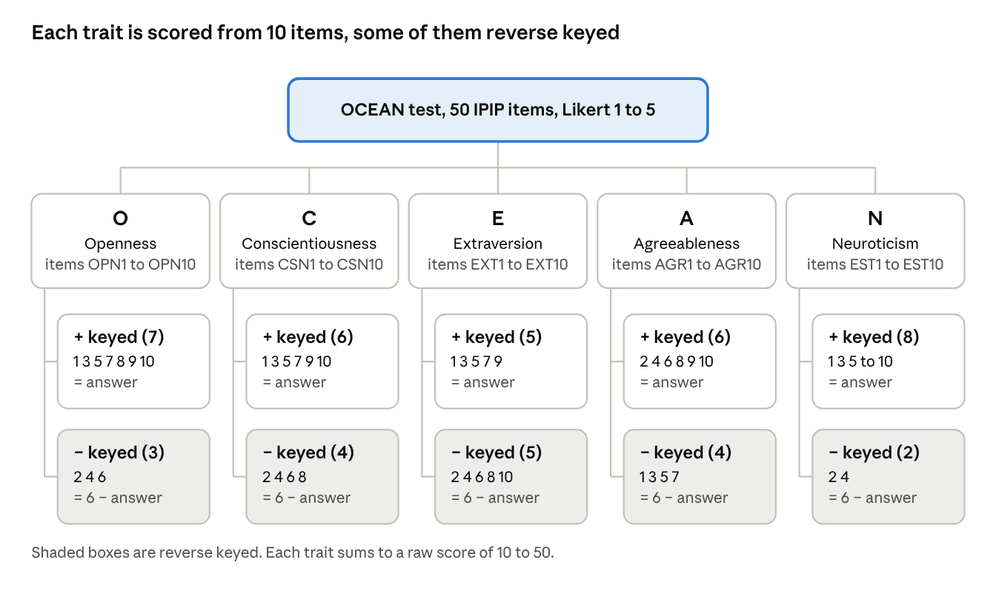
question model tree · 5 traits, 50 items
Extraversion (E)
Q_ID | Item | Key
EXT1 | I am the life of the party. | +
EXT2 | I don't talk a lot. | −
EXT3 | I feel comfortable around people. | +
EXT4 | I keep in the background. | −
EXT5 | I start conversations. | +
EXT6 | I have little to say. | −
EXT7 | I talk to a lot of different people at parties. | +
EXT8 | I don't like to draw attention to myself. | −
EXT9 | I don't mind being the center of attention. | +
EXT10 | I am quiet around strangers. | −
Neuroticism (N), dataset prefix EST
Q_ID | Item | Key
EST1 | I get stressed out easily. | +
EST2 | I am relaxed most of the time. | −
EST3 | I worry about things. | +
EST4 | I seldom feel blue. | −
EST5 | I am easily disturbed. | +
EST6 | I get upset easily. | +
EST7 | I change my mood a lot. | +
EST8 | I have frequent mood swings. | +
EST9 | I get irritated easily. | +
EST10 | I often feel blue. | +
Agreeableness (A)
Q_ID | Item | Key
AGR1 | I feel little concern for others. | −
AGR2 | I am interested in people. | +
AGR3 | I insult people. | −
AGR4 | I sympathize with others' feelings. | +
AGR5 | I am not interested in other people's problems. | −
AGR6 | I have a soft heart. | +
AGR7 | I am not really interested in others. | −
AGR8 | I take time out for others. | +
AGR9 | I feel others' emotions. | +
AGR10 | I make people feel at ease. | +
Conscientiousness (C)
Q_ID | Item | Key
CSN1 | I am always prepared. | +
CSN2 | I leave my belongings around. | −
CSN3 | I pay attention to details. | +
CSN4 | I make a mess of things. | −
CSN5 | I get chores done right away. | +
CSN6 | I often forget to put things back in their proper place. | −
CSN7 | I like order. | +
CSN8 | I shirk my duties. | −
CSN9 | I follow a schedule. | +
CSN10 | I am exacting in my work. | +
Openness (O)
Q_ID | Item | Key
OPN1 | I have a rich vocabulary. | +
OPN2 | I have difficulty understanding abstract ideas. | −
OPN3 | I have a vivid imagination. | +
OPN4 | I am not interested in abstract ideas. | −
OPN5 | I have excellent ideas. | +
OPN6 | I do not have a good imagination. | −
OPN7 | I am quick to understand things. | +
OPN8 | I use difficult words. | +
OPN9 | I spend time reflecting on things. | +
OPN10 | I am full of ideas. | +

8. OCEAN and 9-Box Logic Model (IF-THEN Rules)
The model runs in five layers. Layers 1 to 3 follow the Meridian code (lib/ocean.ts) and turn one employee's 50 answers into percentiles, a decision profile and an executive fit flag. Layer 0 is proposed in this report and is not yet in the prototype, which does not record test time. Layer 4 places the employee on the 9-Box Talent Grid from HR records.

Layer 0. Validity Rules
These rules match the cleaning of the benchmark in section 9, so an employee result is judged by the same standard as the norms.
Rule | IF | THEN
V1 | Any of the 50 items is blank or 0 | Invalid, ask the user to finish the test
V2 | test_seconds < 100 (under 2 seconds an item) | Invalid, answered too fast to be reliable
V3 | test_seconds > 3600 | Invalid, test abandoned and resumed
V4 | Standard deviation of the 50 answers < 0.5 | Invalid, straight lining
V5 | V1 to V4 all pass | Valid, continue to Layer 1

Layer 1. Item Scoring Rules
Rule | IF Q_ID is in | THEN scored value | Add to
I1 | EXT1, EXT3, EXT5, EXT7, EXT9 | answer | E raw
I2 | EXT2, EXT4, EXT6, EXT8, EXT10 | 6 − answer | E raw
I3 | EST1, EST3, EST5, EST6, EST7, EST8, EST9, EST10 | answer | N raw
I4 | EST2, EST4 | 6 − answer | N raw
I5 | AGR2, AGR4, AGR6, AGR8, AGR9, AGR10 | answer | A raw
I6 | AGR1, AGR3, AGR5, AGR7 | 6 − answer | A raw
I7 | CSN1, CSN3, CSN5, CSN7, CSN9, CSN10 | answer | C raw
I8 | CSN2, CSN4, CSN6, CSN8 | 6 − answer | C raw
I9 | OPN1, OPN3, OPN5, OPN7, OPN8, OPN9, OPN10 | answer | O raw
I10 | OPN2, OPN4, OPN6 | 6 − answer | O raw
Each raw trait total runs from 10 to 50 and is stored in TEST_RESULT.

Layer 2. Percentile and Trait Band
Each raw total is looked up in OCEAN_NORM. The percentile is the mid rank of that raw score among the 592,204 cleaned IPIP respondents, rounded to a whole number.
$$P_{t}(\text{raw}) = 100 × \frac{n_{\text{below}} + 0.5 n_{\text{at}}}{592,204}$$
Trait | Percentile at raw 20 | Percentile at raw 30 | Percentile at raw 40
O Openness | 0 | 8 | 51
C Conscientiousness | 4 | 33 | 80
E Extraversion | 18 | 54 | 87
A Agreeableness | 2 | 15 | 58
N Neuroticism | 12 | 46 | 84
The same raw score means very different things across traits. A raw 30 is only the 8th percentile for Openness but the 54th for Extraversion, which is why every rule below uses percentiles.
Rule | IF | THEN
B1 | Percentile < 30 | Trait band = Low
B2 | 30 ≤ percentile < 70 | Trait band = Moderate
B3 | Percentile ≥ 70 | Trait band = High

Layer 3. Knowledge Base, Leadership Index and Decision Profile
The Leadership Index is the mean of the five percentiles weighted by each trait's correlation with leadership in Judge et al. (2002), E 0.31, C 0.28, N −0.24, O 0.24, A 0.08. Neuroticism enters inverted, as emotional stability.
$$\text{LI} = \frac{0.31 P_{E} + 0.28 P_{C} + 0.24 (100 − P_{N}) + 0.24 P_{O} + 0.08 P_{A}}{1.15}$$
Rule | IF | THEN
R1 | Leadership Index ≥ 70 | Flag as executive track (executive fit = Yes)
R2 | Strongest of E, C, S (100 − N), O, A is at or above the 60th percentile | Decision profile = that trait's profile
R3 | No trait reaches the 60th percentile | Decision profile = The Balanced Generalist
R4 | Two traits tie for strongest | The earlier trait in the order E, C, S, O, A wins

Code | Strongest trait | Decision profile | Decision style | Fit in a bank
E | Extraversion | The Mobiliser | Decisive people led driver | Growth mandates, client facing divisions, change programmes
C | Conscientiousness | The Steward | Disciplined process first executor | Risk, compliance, audit and operations leadership
S | Emotional stability (low N) | The Steady Hand | Composed under pressure decider | Incident command, crisis response, treasury
O | Openness | The Visionary | Long horizon systems thinker | Strategy, product innovation, enterprise technology
A | Agreeableness | The Consensus Builder | Trust building collaborative decider | Customer experience, talent, cross functional leadership
B | None at the 60th percentile | The Balanced Generalist | Adaptable situational decider | Rotational and generalist roles
HR can filter the Company Overview to executive fit profiles only when shortlisting for upper management roles.

Layer 4. 9-Box Talent Grid Rules
The grid crosses a performance axis with a potential axis. Both come from the HR datasets and are converted to percentiles among the 17,414 employees.
The performance axis is a weighted mean of last year's rating (50%), the KPI flag (40%) and awards (10%). Employees with no rating, all of them in their first year, are Not rated and get no cell.
$$\text{Perf} = 0.5 × \frac{\text{rating} − 1}{4} + 0.4 × {\text{KPI}}_{\text{>80\%}} + 0.1 × \text{award}$$
The potential axis is a logistic regression trained on hr-ana train.csv (54,808 employees, target is_promoted). Its inputs are the training score relative to department peers (with a hinge above +1 SD), number of trainings, age, length of service, a Master's degree and a referral hire. The model is class balanced, and its 5-fold cross validated AUC is 0.714. Rating, KPI and awards are left out so the two axes carry different information (correlation 0.07).
Rule | IF | THEN
P1 | Index < 33.3 | Band = Low
P2 | 33.3 ≤ index < 66.7 | Band = Medium
P3 | Index ≥ 66.7 | Band = High
P4 | previous_year_rating is blank | Performance band = Not rated, no 9-Box cell

Box | Performance | Potential | Label | Recommended action
1 | Low | High | Enigma | Find the barrier, coach, consider a better fit role
2 | Medium | High | Growth Employee | Stretch assignment and development plan
3 | High | High | Star | Succession pool, retain and prepare for promotion
4 | Low | Medium | Dilemma | Performance plan with close coaching
5 | Medium | Medium | Core Player | Keep engaged, targeted skill training
6 | High | Medium | High Performer | Reward and widen scope to build potential
7 | Low | Low | Underperformer | Performance plan, consider role change
8 | Medium | Low | Average Performer | Clarify goals, keep in current role
9 | High | Low | Solid Performer | Recognize expertise, keep as specialist
The recommended actions and the three combined rules below are proposed in this report and are not yet in the prototype.
Rule | IF | THEN | Employees in file
X1 | 9-Box = Star AND executive fit = Yes | Shortlist for upper management succession | 357
X2 | Executive fit = Yes AND performance band = Low | Leadership traits present but results lag, coach before placement | 765
X3 | 9-Box = Star or Growth Employee AND profile = The Balanced Generalist | Rotational assignment to find a signature style | 276

9. Data Profile and Quality
The model draws on three datasets. After cleaning, 592,204 of the 1,015,341 IPIP responses (58.3%) form the OCEAN norms, and 17,414 employees from the two HR datasets carry the 9-Box axes.

9.1 Dataset Overview
Property | IPIP Big Five Personality Test | hr-ana | Employee's Performance for HR Analytics
Source | Open Psychometrics online test, Kaggle (Tunguz) | Kaggle (arashnic) | Kaggle (sanjanchaudhari)
Files | data-final.csv, codebook.txt | train.csv, test.csv | Uncleaned_employees_final_dataset (1).csv
Granularity | One row per test submission | One row per employee | One row per employee
Data type | Structured, tab separated | Structured CSV | Structured CSV
Volume | 1,015,341 rows × 110 columns | train 54,808 rows, test 23,490 rows | 17,417 rows
Period | 3 March 2016 to 8 November 2018 | One snapshot, no dates | One snapshot, no dates
Used for | OCEAN scores and percentile norms | Potential model (train), employee records (test) | The employees and their KPI flag
The two HR datasets are one population. All 17,414 distinct employees in the performance file are in test.csv and every shared column agrees, so the file is effectively test.csv with a KPI column added. train.csv is a separate group with no overlap, and it is the only file with is_promoted, so promotion is modelled rather than joined.
The build script (data/build_ocean_dataset.py, fixed seed 42) combines the sources into employees_ocean_hr.csv, 17,414 rows × 36 columns. In the system, one IPIP row maps to one TEST_RESULT with 50 ANSWER rows, and one employee row maps to one HR_RECORD and one TALENT_REVIEW.
The OCEAN columns in the employee file are a synthetic link. The personality data and the HR data come from different people and share no key. Each employee is paired with a real, anonymous IPIP respondent chosen so the combined data behaves the way published research says it should. The file is fine for building and demonstrating the DSS, but it is not evidence.
- Trait and performance correlations were set on purpose (targets from Sackett et al. 2022), so finding them again proves nothing.
- Department differences in personality are assumptions, not findings.
- Personality was matched only on department and performance, so any pattern with age, gender, region or education is meaningless.
- It must not be used for real decisions about real people.

9.2 Data Dictionary
IPIP Big Five (data-final.csv)
Field | Type | Description | Valid range | Example
EXT1 to EXT10 | int | Extraversion item answers | 1 to 5 (0 = skipped) | 4
EST1 to EST10 | int | Neuroticism item answers (named Emotional Stability in the file, high means less stable) | 1 to 5 (0 = skipped) | 2
AGR1 to AGR10 | int | Agreeableness item answers | 1 to 5 (0 = skipped) | 4
CSN1 to CSN10 | int | Conscientiousness item answers | 1 to 5 (0 = skipped) | 3
OPN1 to OPN10 | int | Openness item answers | 1 to 5 (0 = skipped) | 5
EXT1_E to OPN10_E | int | Milliseconds on each item | ≥ 0 | 9419
dateload | datetime | Time the survey started | 2016-03-03 to 2018-11-08 | 2016-03-03 02.01.01
testelapse | int | Seconds on the question page | 100 to 3,600 used | 234
IPC | int | Records from the same IP address | 1 used | 1
country | string | Country code from technical information | ISO 2 letter or NONE | GB
screenw, screenh, introelapse, endelapse, latitude, longitude | mixed | Device, page timing and approximate location | Not used in scoring | 768, 1024
HR fields (hr-ana and Employee's Performance)
Field | Type | Description | Observed range | Example
employee_id | int | Source employee ID | 17,414 unique | 3
department | string | Meridian department, mapped from source_department | 6 departments | Corporate Banking
source_department | string | Original department | 9 values | Procurement
region | string | Anonymized region | 34 values | region_22
education | string | Highest education | Bachelor's, Master's and above, Below Secondary, Unknown | Master's and above
gender | string | Gender | m, f | f
recruitment_channel | string | How the employee was hired | other, sourcing, referred | other
age | int | Age in years | 20 to 60 | 38
length_of_service | int | Years of service | 1 to 34 | 4
no_of_trainings | int | Trainings attended | 1 to 9 | 1
avg_training_score | int | Average training score | 39 to 99 | 67
previous_year_rating | int | Last year's rating, blank for 1,363 first year employees | 1 to 5 | 5
kpis_met_more_than_80 | int | 1 if more than 80% of KPIs were met | 0, 1 | 1
awards_won | int | 1 if an award was won | 0, 1 | 0
is_promoted | int | Promotion outcome, train.csv only, target of the potential model | 0, 1 | 1
performance_index, potential_index | decimal | Derived percentiles for the two 9-Box axes | 0 to 100 | 92.2, 75.5
nine_box, nine_box_label | int, string | Derived 9-Box cell | 1 to 9 or Not rated | 3, Star
decision_profile, leadership_index, executive_fit | mixed | Derived from the linked OCEAN scores | Six profiles, 0 to 100, Yes or No | The Steward, 42.6, No

9.3 Completeness
Dataset and column | Missing | % of rows | Decision
IPIP, all items and times blank | 1,783 rows | 0.18% | Drop, nothing to score
IPIP, any item coded 0 (skipped) | 139,124 rows | 13.70% | Drop, a trait cannot be scored with a missing item
IPIP, screenw, screenh, introelapse | 2,066 rows | 0.20% | Keep, not used in scoring
IPIP, country blank or NONE | 13,805 rows | 1.36% | Keep, recode to Unknown
HR, previous_year_rating | 1,363 of 17,414 | 7.8% | Keep, all are first year employees, set to Not rated with no 9-Box cell
HR, education | 771 of 17,414 | 4.4% | Keep as Unknown
HR, every other column | 0 | 0% | Keep
Raw train.csv, education | 2,409 of 54,808 | 4.40% | Keep as Unknown in the potential model
Raw train.csv, previous_year_rating | 4,124 of 54,808 | 7.52% | Keep, rating is not a model input
Raw test.csv, education | 1,034 of 23,490 | 4.40% | Keep as Unknown for joined employees
Raw test.csv, previous_year_rating | 1,812 of 23,490 | 7.71% | Keep, set to Not rated for joined employees
Raw performance file, education | 771 of 17,417 | 4.43% | Keep as Unknown
Raw performance file, previous_year_rating | 1,363 of 17,417 | 7.83% | Keep, set to Not rated
The first HR rows come from the employee file, whose HR columns are the source values cleaned. The rows marked Raw show each source file before the join, and every other column in those files has no missing values.

9.4 Accuracy
Check | Finding | Decision
IPIP item answers | All non blank values are 0 to 5, and 0 means skipped (0.73% of cells) | Rows with 0 dropped
IPIP testelapse | Median 224 s, 1st percentile 91 s, max 11,892,718 s (about 138 days). 25,656 rows (2.5%) fall outside 100 to 3,600 s | Keep 100 to 3,600 s (rules V2 and V3)
IPIP item times | 826 negative cells and 13 cells at 2,147,483,647, the 32 bit integer limit | Keep rows, times not used in scoring
IPIP screen size | 2,724 rows with width and height of 0 | Keep, not used
HR age and service | Age 20 to 60, service 1 to 34 years, and service never exceeds age minus 18 | No action
HR scores and flags | Training score 39 to 99, rating 1 to 5, KPI and award flags only 0 or 1 | No action
HR outliers (1.5 × IQR rule) | age: 453 rows (2.6%) above 54. length_of_service: 1,083 rows (6.2%) above 13 years. avg_training_score: 0 rows. no_of_trainings: the IQR is 0 because most employees attended once, so the rule flags 3,356 rows (19.3%) that are not errors | Keep all, the values are plausible for a workforce and inside the valid ranges

9.5 Consistency
Check | Finding | Decision
IPIP repeated submissions | 318,496 rows (31.4%) share an IP address (IPC > 1) | Keep IPC = 1 only, as the codebook advises
IPIP straight lining | 6,574 rows (0.6%) have an answer SD under 0.5, which contradicts the reverse keyed items | Drop (rule V4)
IPIP trait label | The EST prefix is named Emotional Stability, but positive items measure Neuroticism | Report the trait as N
HR surplus rows | The performance file has 3 more rows than distinct employees, of which 2 are exact duplicates (employee 49584) and 1 conflicts with test.csv (employee 64573) | Treat test.csv as correct, take only employee_id and the KPI flag from the performance file
HR education labels | Spelled two ways across files (Bachelors and Bachelor's, Masters & above and Master's & above) | Standardize to one spelling
HR first year ratings | 135 employees with 1 year of service still have a previous year rating | Keep, flag for HR to check
HR duplicate IDs | 0 duplicate employee_id in the employee file | No action
HR department names | Source departments do not match Meridian's | Map with the table below, keep source_department for audit

Source department | Meridian department | Employees
Sales and Marketing | Retail Banking | 5,458
Operations | Customer Service | 3,524
Procurement, Legal | Corporate Banking | 2,572
Technology, R&D | IT Support | 2,531
Finance, Analytics | Finance and Accounting | 2,499
HR | Human Resources | 830

9.6 Data Cleaning Workflow
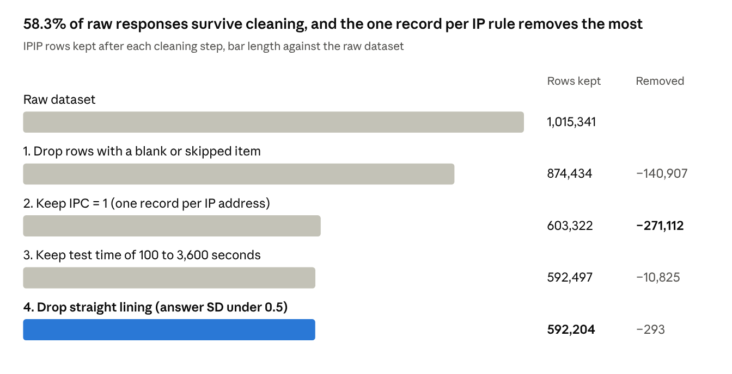
data-final.csv · 1,015,341 raw rows, 4 cleaning steps, same rules as build_ocean_dataset.py
After the filters, the IPIP data is reverse keyed (18 items), summed to raw totals of 10 to 50, and turned into the OCEAN_NORM lookup. Cronbach's alpha is 0.80 to 0.90 per trait, so each 10 item scale is reliable.
The HR data goes through seven steps.
- Remove the 3 surplus rows from the performance file (17,417 to 17,414) and keep only employee_id and the KPI flag.
- Join to hr-ana test.csv on employee_id, one to one.
- Standardize education, and turn blanks into Unknown.
- Map the 9 source departments to 6 Meridian departments.
- Compute the performance index for rated employees and the potential index from the model trained on train.csv.
- Band both axes into thirds and assign the 9-Box cell.
- Link each employee to one cleaned IPIP respondent by statistical matching within the department, tilted by the assumed department differences below.
Department | Assumed tilt (SD)
Retail Banking | E +0.30, A +0.10
Corporate Banking | E +0.20, C +0.20
Customer Service | A +0.30, N −0.10
Finance and Accounting | C +0.30, E −0.10
IT Support | O +0.30, E −0.20
Human Resources | A +0.20, E +0.20

9.7 Data Analysis, OCEAN Benchmark
Openness and Agreeableness score high for most people, while Extraversion is the most spread out trait.
Trait | Mean raw | SD | Q1 | Median | Q3 | Cronbach's alpha
O Openness | 39.4 | 6.2 | 35 | 40 | 44 | 0.80
A Agreeableness | 37.6 | 7.4 | 33 | 39 | 43 | 0.84
C Conscientiousness | 33.4 | 7.4 | 28 | 34 | 39 | 0.82
N Neuroticism | 30.8 | 8.6 | 25 | 31 | 37 | 0.87
E Extraversion | 29.1 | 9.1 | 22 | 29 | 36 | 0.90
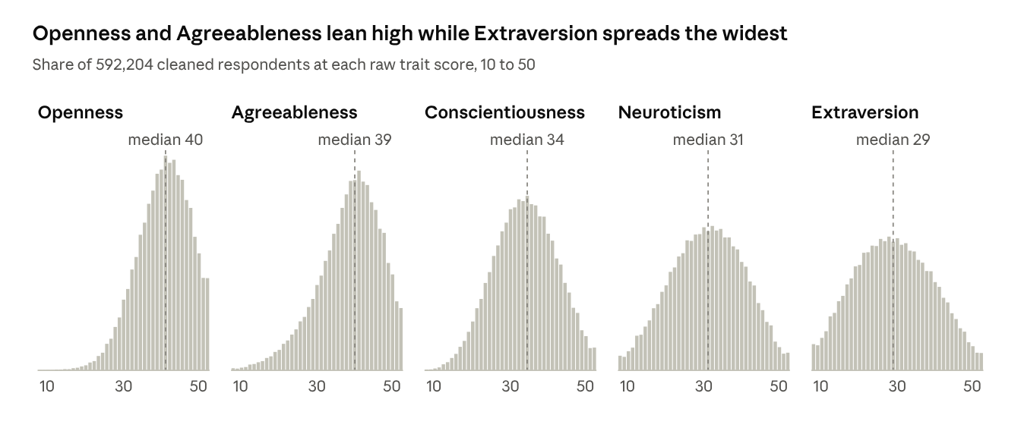
data-final.csv, cleaned · 592,204 respondents, raw scores 10 to 50
Openness and Agreeableness pile up at the high end, so a high raw score on these two is common and the percentile matters more than the raw value. Extraversion and Neuroticism spread across almost the whole scale.
Correlation between traits (Pearson, n = 592,204)
 | O | C | E | A | N
O | 1.00 | 0.05 | 0.18 | 0.10 | −0.08
C | 0.05 | 1.00 | 0.07 | 0.14 | −0.24
E | 0.18 | 0.07 | 1.00 | 0.31 | −0.22
A | 0.10 | 0.14 | 0.31 | 1.00 | −0.04
N | −0.08 | −0.24 | −0.22 | −0.04 | 1.00
The traits are mostly independent, which supports scoring them separately. The strongest link is Extraversion with Agreeableness (0.31). Neuroticism falls as Conscientiousness (−0.24) and Extraversion (−0.22) rise. The Leadership Index inverts N for a separate reason, its negative correlation with leadership in Judge et al. (2002).
Mean raw score by country (largest eight plus Thailand)
Country | Valid rows | O | C | E | A | N
US | 295,034 | 39.6 | 34.1 | 29.4 | 38.4 | 30.4
GB | 42,693 | 39.5 | 32.3 | 29.2 | 36.9 | 31.9
CA | 37,629 | 39.6 | 33.6 | 29.1 | 37.8 | 30.7
AU | 29,909 | 39.0 | 33.6 | 29.5 | 37.9 | 30.6
DE | 10,759 | 41.1 | 32.1 | 28.3 | 36.1 | 30.3
IN | 9,646 | 38.2 | 33.5 | 29.5 | 37.3 | 31.4
PH | 9,220 | 36.8 | 33.5 | 27.6 | 36.4 | 32.6
MX | 8,181 | 38.8 | 31.9 | 29.1 | 35.6 | 32.1
TH | 1,311 | 37.3 | 33.5 | 29.3 | 36.5 | 29.6
Thai respondents score lower on Openness (37.3 against 39.4 overall) and have the lowest Neuroticism in this group (29.6). The Steady Hand is their most common profile (24.5%), and 10.0% of them are executive fit against 12.3% overall. The norms are a global online sample, not Thai bankers, so HR can add a Thailand only norm once enough employees have taken the test.

9.8 Data Analysis, HR and 9-Box
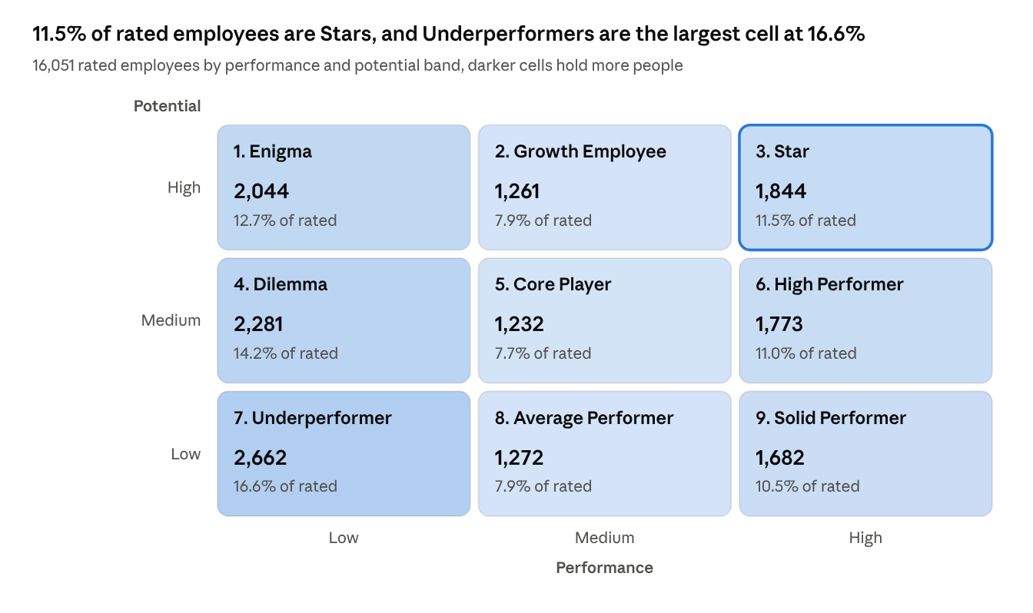
employees_ocean_hr.csv · 16,051 rated employees, 1,363 first year employees not rated
The performance axis is lopsided because its inputs are coarse and many people tie, so the Low band holds 6,987 people and the Medium band only 3,765. The potential axis splits into even thirds.
Department | Employees | KPI met > 80% | Mean training score | Executive fit | Star | Underperformer
Retail Banking | 5,458 | 27.7% | 50.1 | 15.5% | 7.7% | 19.5%
Customer Service | 3,524 | 44.1% | 60.4 | 14.4% | 11.8% | 10.9%
Corporate Banking | 2,572 | 37.1% | 68.8 | 15.9% | 10.8% | 18.3%
IT Support | 2,531 | 36.8% | 80.5 | 11.4% | 13.1% | 13.9%
Finance and Accounting | 2,499 | 39.9% | 76.8 | 13.9% | 11.2% | 12.2%
Human Resources | 830 | 36.0% | 50.3 | 14.5% | 14.3% | 10.5%
The HR columns are real source values, and the shares in this table use all employees in each department. Retail Banking has the lowest KPI attainment (27.7%) and the highest Underperformer share (19.5%), so it is the first department for a performance review. Training scores differ widely by department (50.1 to 80.5), which is why the potential model compares each employee with department peers.
Correlation between HR fields (Pearson, 17,414 employees, 16,051 for rating)
 | Rating | KPI | Award | Training | Age | Service | Trainings
Rating | 1.00 | 0.34 | 0.04 | 0.06 | 0.02 | 0.01 | −0.05
KPI | 0.34 | 1.00 | 0.11 | 0.07 | −0.03 | −0.08 | −0.05
Award | 0.04 | 0.11 | 1.00 | 0.08 | 0.00 | −0.04 | 0.00
Training | 0.06 | 0.07 | 0.08 | 1.00 | −0.03 | −0.03 | 0.05
Age | 0.02 | −0.03 | 0.00 | −0.03 | 1.00 | 0.64 | −0.09
Service | 0.01 | −0.08 | −0.04 | −0.03 | 0.64 | 1.00 | −0.06
Trainings | −0.05 | −0.05 | 0.00 | 0.05 | −0.09 | −0.06 | 1.00
Rating and the KPI flag agree only moderately (0.34), so using both gives the performance axis more information than either alone. Age and service move together (0.64), as expected. Training score has almost no link with rating or KPI (0.06 and 0.07), which fits its use on the separate potential axis. These are real HR values, so unlike the personality columns they can be read as patterns in the data.
The personality columns behave as they were built to. Each department's most common profile matches its assumed tilt, for example The Visionary in IT Support (26.2%) and The Steward in Finance and Accounting (27.5%). Executive fit is 19.4% among Stars against 10.9% among Underperformers, which only reflects the built in link between Conscientiousness and performance. These patterns confirm that the matching worked and are not findings about employees. Performance and potential are nearly independent (correlation 0.07), so the two axes add different information.

References
arashnic. (n.d.). hr-ana [Data set, train.csv and test.csv]. Kaggle. https://www.kaggle.com/datasets/arashnic/hr-ana
Goldberg, L. R. (1992). The development of markers for the Big-Five factor structure. Psychological Assessment, 4(1), 26 to 42.
Group 03. (2026). Meridian OCEAN Executive DSS, README.md and data/README.md [Project source code and documentation].
International Personality Item Pool. (n.d.). Administering IPIP measures, with a 50-item sample questionnaire. https://ipip.ori.org/newBigFive5broadKey.htm
Judge, T. A., Bono, J. E., Ilies, R., & Gerhardt, M. W. (2002). Personality and leadership, a qualitative and quantitative review. Journal of Applied Psychology, 87(4), 765 to 780.
Sackett, P. R., Zhang, C., Berry, C. M., & Lievens, F. (2022). Revisiting meta-analytic estimates of validity in personnel selection. Journal of Applied Psychology, 107(11), 2040 to 2068.
sanjanchaudhari. (n.d.). Employee's Performance for HR Analytics [Data set]. Kaggle. https://www.kaggle.com/datasets/sanjanchaudhari/employees-performance-for-hr-analytics
Tunguz, B. (2020). Big Five Personality Test [Data set, IPIP-FFM-data-8Nov2018 with codebook]. Kaggle. https://www.kaggle.com/datasets/tunguz/big-five-personality-test

